.venv
Using it to create a space for one project. Eg 2 different projects can use different versions of pandas/numpy
We can install libraries using terminals.
Ipynb for markdown
From apples table I chose the closing price to identify the trend because high could be temporarily spkied and same with low. Volume is does not tell the price and date is irrelevant.
• Method: A function that belongs to an object, e.g., apple.plot() or apple.head().
• Function: A standalone command provided by a library, e.g., plt.xlabel().
• plt is an alias for matplotlib.pyplot, making the code shorter and easier to read.
• plt.xlabel() labels the horizontal (x) axis.
• plt.ylabel() labels the vertical (y) axis.
Why save datasets instead of downloading them every time?
- It saves time because Python reads the file from the computer instead of downloading it again.
- It reduces internet dependency.
- It preserves any cleaning or preprocessing already done.
- It ensures everyone uses the same dataset, making the analysis reproducible.
Why use CSV?
- CSV stands for Comma-Separated Values.
- It stores data in rows and columns using commas to separate values.
- It is easy for pandas to read into a DataFrame.
- It is lightweight and widely supported by many software tools, including Python, Excel, and R.
- It is one of the most common file formats used in data science.
Raw vs Processed Data
- Raw data is the original data exactly as it was collected or downloaded.
- Processed data is data that has been cleaned, transformed, or enhanced for analysis.
- Keeping raw and processed data separate helps preserve the original dataset and makes projects easier to reproduce.
Relative File Paths
A relative file path tells Python where a file is located relative to the current project.
Example:
apple.to_csv("data/raw/apple_stock.csv")
Python reads this as:
- Go into the data folder.
- Then go into the raw folder.
- Save the file as apple_stock.csv.
## Day 2 - Data Collection and Visualization
- A DataFrame is a table containing rows and columns of data.
- A Series is a single column extracted from a DataFrame.
- Methods belong to objects (e.g., head(), plot(), to_csv()).
- Functions belong to libraries (e.g., plt.title(), plt.xlabel()).
- The Close price is commonly used to analyze long-term stock performance because it represents the market's final price for the day.
- Graphs make trends easier to identify than large tables of numbers.
- CSV (Comma-Separated Values) is a common format for storing tabular data because it is lightweight and compatible with many tools.
- Raw data is the original downloaded dataset.
- Processed data has been cleaned or transformed for analysis.
- Relative file paths tell Python where to save or load files within a project.
Why don't we just print the whole dataset?
Many datasets contain thousands or even millions of rows. Printing everything would:
- clutter the screen,
- slow down the notebook,
- make it difficult to inspect the data.
head() gives a quick preview instead.
"To predict future stock performance the Close column would be ideal."
Why?
The Close price is the final price of a stock at the end of the trading day. It reflects the market's consensus after all trading has finished for that day.
Most forecasting models use the Close price because:
- It is the standard price reported in financial analysis.
- It contains the day's final market information.
- It is less noisy than trying to predict the intraday High or Low.
info() provides a summary of a DataFrame, including the number of rows, non-null values, data types of each column, and memory usage. It is one of the first commands used to inspect a dataset before cleaning or analysis.
Store data in the most useful format.
Why didn't we convert the Volume column to a string?
We keep Volume as an integer because it represents a numerical quantity (the number of shares traded). If we convert it to a string, Python will treat it as text instead of a number. As a result, we won't be able to perform mathematical operations such as calculating the average trading volume, finding the maximum volume, or creating numerical analyses without converting it back to a numeric type
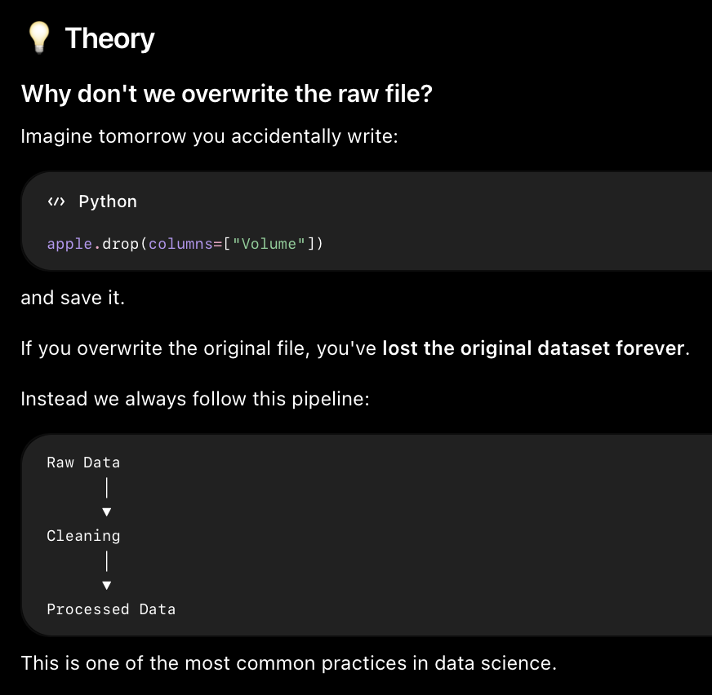
Why don't we keep only the processed dataset?
Because:
- The raw dataset is the original source of truth.
- If we make a mistake while cleaning, we can always start again.
- It makes the project reproducible.
- Other people can verify exactly what transformations we performed.
Why do we use index=False?
to tell pandas:
"Save only my actual data, not your internal row numbers."
Data validation means asking:
"Can I trust my data before I start analyzing it?"
Today you validated:
- ✅ Same structure
- ✅ Same variables
- ✅ No missing values
- ✅ No duplicate records
- ✅ Correct date format
Only after validation do we move on to analysis.
## Day 1

### Completed
- Created the main project folders
- Created README.md
- Created .gitignore
- Created requirements.txt
- Set up the basic project structure
- Set up virtual environment
- Installed required libraries
- Created GitHub repository
- Wrote initial README

### Learned
- What a README file is used for
- What .gitignore does
- Why a virtual environment is useful (.venv)

### What is `.gitignore`?

A `.gitignore` file tells Git which files or folders it should ignore and not upload to GitHub.

Think of it as a "Do Not Upload" list.

---

### Why do we need it?

Some files are automatically created by Python, VS Code, macOS, or other software.

These files are temporary or specific to my computer, so they don't need to be shared with anyone else.

Keeping them out of GitHub makes the project cleaner.

---

### Why do we ignore `.venv/`?

`.venv` contains my project's virtual environment.

It includes Python and all the installed libraries.

Every developer creates their own virtual environment, so uploading mine is unnecessary and can make the repository very large.

Instead, I upload `requirements.txt`, which lists all the libraries needed to recreate the environment.

---

### Why ignore `__pycache__/`?

Python automatically creates this folder to make programs run a little faster.

These files are temporary and can always be recreated.

---

### Why ignore `*.pyc`?

These are compiled Python files that Python generates automatically.

They are not part of my actual code and don't need to be uploaded.

---

### Why ignore `.ipynb_checkpoints/`?

Jupyter Notebook automatically creates backup files while I'm working.

These are only for recovery and shouldn't be part of the project.

---

### Why ignore `.DS_Store`?

This is a macOS system file that stores Finder settings like icon positions and folder views.

It has nothing to do with my project.

---

### Important takeaway

GitHub should only contain files that someone else needs to run or understand my project.

Everything that can be recreated automatically should usually be ignored.

Git
- Tracks changes in my project.
- Lets me save checkpoints using commits.

GitHub
- Stores my Git project online.
- Makes it easy to share my work.

Commit
- A snapshot of my project at a specific point in time.

README
- The front page of my project.

.gitignore
- Tells Git which files not to upload.

If Apple's mean closing price is 198.78 but the maximum is 339.79, does that mean Apple usually traded around $340?
No. The maximum is just the highest closing price reached on a single trading day during the five-year period. It doesn't represent where the stock traded most of the time.
The mean (198.78) is the average of all 1,255 trading days, so it represents the overall average closing price across the entire timeline.
Since the mean ($198.78) is higher than the median ($187.02), it suggests that some relatively high stock prices (like those above $300) pulled the average upward. This is common in data where there are some unusually large values.

• describe() provides a quick statistical summary of numerical data.
• The mean is the average of all observations.
• The median is the middle value and is less affected by extreme values than the mean.
• Minimum and maximum show the range of the data.
• Standard deviation measures how much the data varies from its average.
• If the mean is noticeably higher than the median, it may indicate that some larger values are pulling the average upward.
Add this to your "What I Learned" notes
- A line graph is ideal for showing how a value changes over time.
- The x-axis usually represents time, while the y-axis represents the variable being measured.
- Stock prices often fluctuate daily, but the overall trend can still be upward or downward.
- Visualizations help identify trends and patterns much faster than tables of numbers.
⭐ This is the mindset I want you to build
When you look at a graph, ask yourself these questions:
- What pattern do I see?
- When did it happen?
- How large was the change?
- What evidence would I need to explain it?
Add this to your "What I Learned" notes
- A graph helps identify patterns, but it does not prove the cause of those patterns.
- As a data analyst, it's important to distinguish observation ("the stock price dropped") from explanation ("it dropped because of..."), which requires additional evidence.
- When analyzing a graph, start by identifying the trend, volatility, unusual points, and questions that need further investigation.
The stock experiences short-term volatility, which may be influenced by company-specific events (Short-Term Volatility: This means the stock price swings sharply up or down over days, weeks, or months, but it does not mean the long-term value of the company has permanently changed.)

This is an important distinction in data science:
A graph shows patterns. It doesn't prove causes.
✅ 4. Lowest point
"The lowest it ever got in this timeline was 2023, so it would be interesting to figure out that reason as a data analyst."
Excellent observation.
This is exactly how analysts think.
Instead of saying:
"Apple dropped because of X."
You ask:
"Why did Apple reach its lowest point around early 2023? Let's investigate."
That investigation might involve:
- Looking at financial news
- Reviewing earnings reports
- Comparing with the Nasdaq or S&P 500
- Checking interest rate announcements
- Looking at economic events
That's the difference between describing data and explaining data.
When you look at a graph, ask yourself these questions:
- What pattern do I see?
- When did it happen?
- How large was the change?
- What evidence would I need to explain it?
- • A graph helps identify patterns, but it does not prove the cause of those patterns.
- • As a data analyst, it's important to distinguish observation ("the stock price dropped") from explanation ("it dropped because of..."), which requires additional evidence.
- • When analyzing a graph, start by identifying the trend, volatility, unusual points, and questions that need further investigation.
"What additional information would you like to have to better understand these price movements?"
"I'd like to investigate major global or company-specific events that occurred around the dates of the significant price movements."
An experienced data analyst might also say they'd want:
- Company events
  - Quarterly earnings reports
  - Product launches (e.g., new iPhone, Mac, AI announcements)
  - CEO announcements
  - Dividend or stock buyback announcements
- Economic events
  - Inflation reports
  - Interest rate decisions by the Federal Reserve
  - Recession concerns
  - Major geopolitical events
- Market comparison
  - Was only Apple falling?
  - Or was the entire tech sector (Microsoft, Nvidia, Google) falling too?
This last point is especially important.
Imagine Apple dropped 15%.
- If Apple alone dropped, the reason might be company-specific.
- If every tech stock dropped, the reason is probably a broader market event.
That's how analysts narrow down the cause.
📝 Add this to your "What I Learned" notes
- plt.figure(figsize=(width, height)) creates the canvas before plotting.
- The first number controls the width, and the second controls the height.
- A wider figure makes dates and labels easier to read.
📝 Add this to your "What I Learned" notes
- plt.grid() adds horizontal and vertical guide lines to the graph.
- A grid improves readability and helps estimate values more accurately.
- It doesn't change the data—it only improves the visualization.
📝 Add this to your "What I Learned" notes
- color="green" changes the line color.
- linewidth=3 changes the thickness of the line.
- These parameters are added inside plt.plot() because they modify the line itself.
plt.plot( x, y, color="green", linewidth=3 )
📝 Final "What I Learned" Notes (Day 4)
These are the notes I'd save if I were reviewing this project a month from now.
Data Analysis
- describe() summarizes numerical data using count, mean, standard deviation, minimum, quartiles, and maximum.
- A graph shows what happened, but not why it happened.
- Observations should be separated from explanations. Evidence is needed before concluding the cause of a trend.
- Line graphs are best for time-series data because they clearly show trends over time.
Matplotlib
- matplotlib.pyplot is used to create graphs.
- plt.figure(figsize=(width, height)) creates the plotting canvas.
- plt.plot(x, y) creates a line graph.
- Optional parameters such as color and linewidth customize the appearance of the graph.
- plt.title(), plt.xlabel(), and plt.ylabel() improve readability.
- plt.grid() adds guide lines to make values easier to estimate.
- plt.show() displays the completed graph.
Analytical Thinking
- Always ask:
  - What trend do I observe?
  - Is there any unusual movement?
  - What additional information would I need to explain it?
- A good analyst forms hypotheses but looks for evidence before reaching conclusions.

